------------------------ START TRANSMISSION ------------------------
YOUR FORCE IS ORDERED TO THE RENORSAL SYSTEM TO RECOVER STAR LEAGUE DEFENSE FORCE EQUIPMENT. RENORSAL WAS PART OF THE TRADERS DOMAIN 2730 LAND RUSH FOR RARE METALS. THE SLDF SENT THE 61ST ROYAL JUMP INFANTRY DIVISION TO GARRISON TRADERS DOMAIN TO MONITOR THE RESOURCES. 61 RJID WAS DEPLOYED TO SUPPORT THE SLDF RESPONSE TO THE AMARIS CIVIL WAR. FOLLOWING THE AMARIS CIVIL WAR THE 61 RJID LEFT THE INNER SPHERE AS PART OF OPERATION EXODIUS. LOCAL SCAVENGERS REPORTEDLY ARE WILLING TO SELL INFORMATION ON THE LOCATION OF 61 RIJD HIDDEN SUPPLY CACHES. YOUR FORCE IS ORDERED TO RECOVER AS MUCH SLDF EQUIPMENT AS POSSIBLE.
------------------------- END TRANSMISSION -------------------------

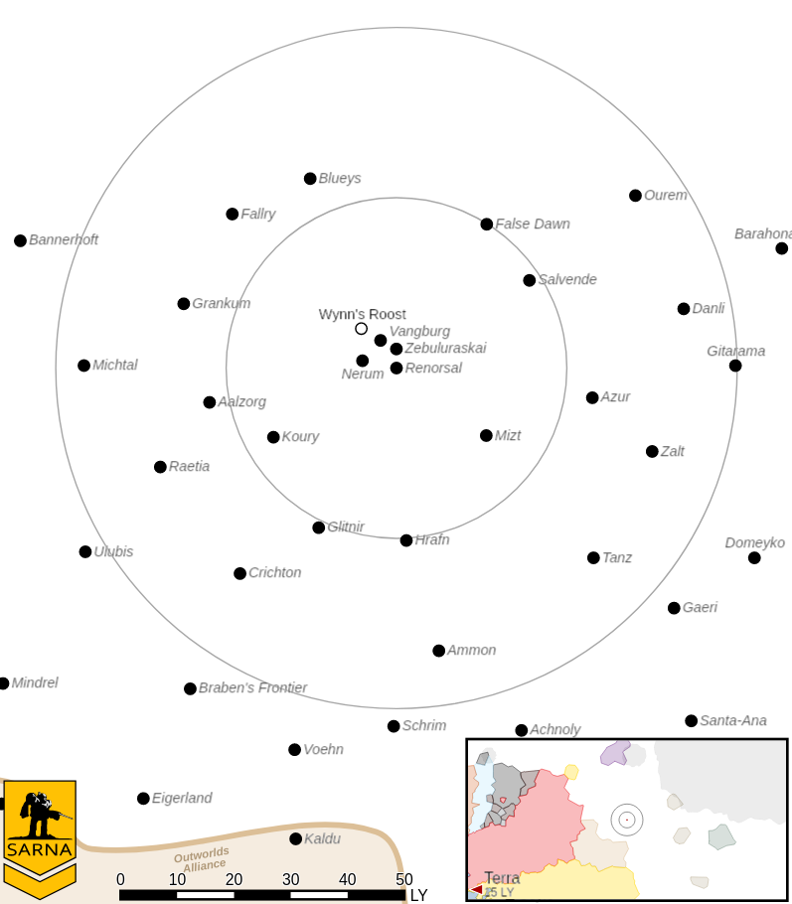
------------------------ START TRANSMISSION ------------------------
THE LEADER OF A GROUP OF LOCAL SCAVENGERS ON RENORSAL III IS WILLING TO EXCHANGE INFORMATION ON THE LOCATION OF 61 RJID SUPPLY CACHES FOR EMPLOYMENT AND TRANSPORTATION OFF WORLD. EXTRACTION WILL BE IN THE EQUATORIAL FORESTS. THE FINAL LOCATION WILL BE CONFIRMED BY RADIO TRANSMISSION WHEN YOUR FORCE REACHES THE AREA.
------------------------- END TRANSMISSION -------------------------

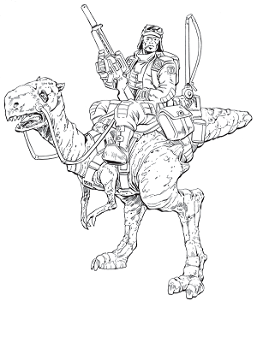

The attacker's primary objective is to extract the scavenger leader by having a unit carry them to the attacker's home edge. The defender's primary objective is to steal the scavenger leader by having a unit carry them to the defender's home edge. A secondary objective for all commanders is to cripple or destroy an enemy mech. The secondary objective can only be awarded once per side.

------------------------ START TRANSMISSION ------------------------
CLAN FORCES SUCCESSFULLY EXTRACTED THE SCAVENGER LEADER. MERCENARY FORCES WERE DECEIVED BY A FEINTING MANEUVER AND WERE UNABLE TO RESPOND IN TIME TO INTERCEPT THE CLAN VTOL EXTRACTING THE SCAVENGER LEADER. TARIQ MOUNTED INFANTRY PLATOONS WERE SEEN NEAR CLAN DROPSHIP ASSETS FOLLOWING THE EXTRACTION.
------------------------- END TRANSMISSION -------------------------

